ASP.NET Web Application

Group Members

**Ben - 5101965116**

**Michael - 3100553617**

**Corey - 0100601817**

**Waleed - 6100758617**

**Andrei Rico – 3106107616**

**Table of Contents**

Contents

Overview - Waleed: 3

Purpose - Waleed: 3

Create Use case diagrams - Corey: 3

Create Class diagrams - All: 4

Database Logical Design: 4

Identify project entities – Andrei: 5

Establish entity-relationships - Ben 6

Complete E-R diagram (to 3NF) FIG 1 – Michael: 6

Complete table data structures 7

List table columns/attributes 7

Identify primary and foreign keys 7

Create test data 7

GUI Design – All : 8

Complete TOE charts – Andrei: 11

Complete GUI design 13

# Overview - Waleed:

A hypothetical company has approached our team to build a software in desktop solution using C# language, we have setup a meeting with general manager (David Hunt) and project manager (Scott Green) of the company to discuss the project requirements and company’s future direction. Five team members ( Ben, Cory, Michael, Andrei, Waleed) working on this project to complete and meet the deadlines by 16/11/2017. Each member is doing their own task to contribute their part in the project. We have given TechSupport name to the application. Which is mainly consist of six tables and home page as well. All tables are connected together and main table is Incident table that have row from technical support and customer table. Each table contains information related to company history. Customer table contains information about company customers, Technicians table contain information about technical support members in the company, and furthermore Registration table have all the product history of each customer their states, zip codes and all. Tables have different options and buttons, where users can Add, delete, Register, products. Users can add extra information and descriptions about products and customers. This program can install and uninstall on the OS and can be run in Windows, Mac, and Linux. We are taking care of documentation with each detail and updates using MS project, creating TOE charts, ER diagrams, Class Diagrams, GUI Diagrams and we are using Database.

# Purpose - Waleed:

The main purpose of this software is to keep the records of products, customers, and their details including date, area, zip codes, Email address, phone numbers and a unique ID, which make search simpler. This Application can register new product under the name of customer with details. It’s a cool app with many features specially designed for organizations to store their customer and products data easily.

# Create Use case diagrams - Corey:

User 1. Menu – A. Product Maintenance – B. Technician Maintenance – C. Incident Form – Add Incident – D. Add Registration.

**Use Case Diagram**

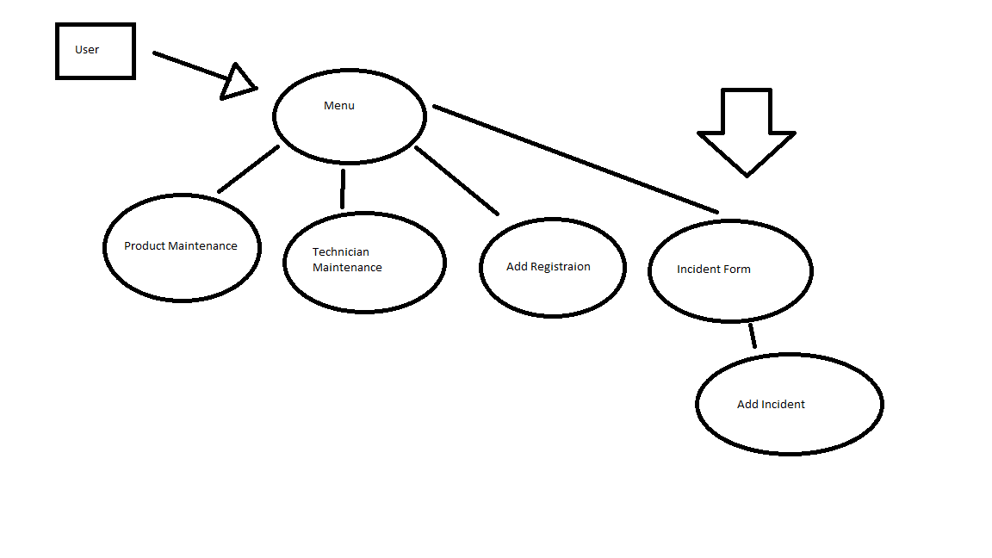

User enters through a menu system, giving prompts to four options including product maintenance, technician maintenance, add registration and incident form. Additionally from incident form the user can move further to add incident. All Pages will have a way to return to the menu page.

# Create Class diagrams - All:

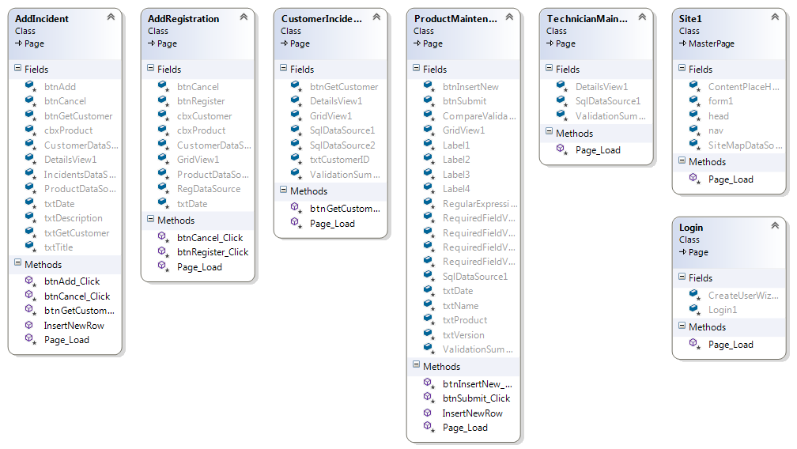

# Database Logical Design:

**(Ben, Andrei, Waleed, Michael, Corey)**

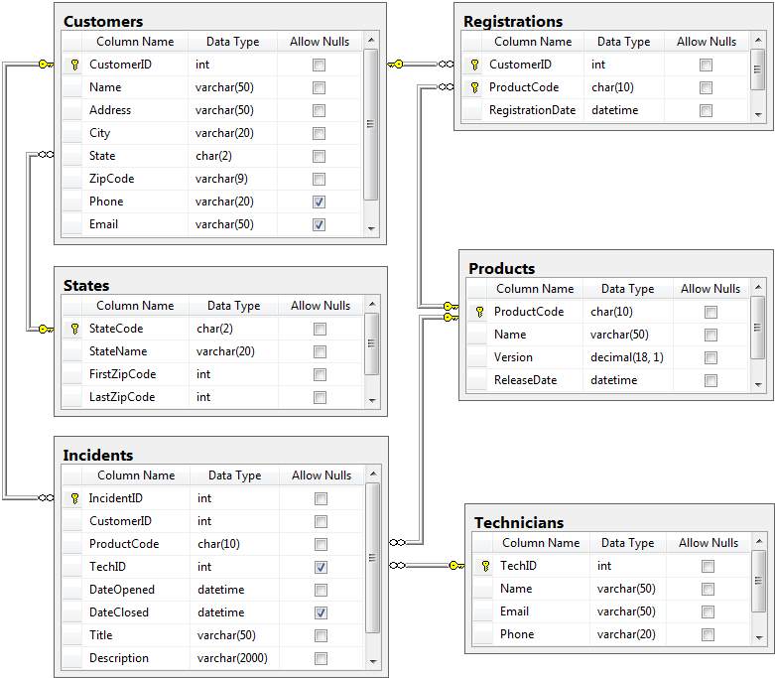

# Identify project entities – Andrei:

|  |  |
| --- | --- |
| User | account |
| ~~Name~~ | customers |
| ~~DOB~~ | incidents |
| ~~Email~~ | technicians |
| ~~Contact number~~ | products |
| ~~username~~ | Level 1 support |
| ~~password~~ | Admin |
| ~~Customer ID~~ | ~~Incident ID~~ |
| ~~Tech Id~~ | Level 2 Support |
| Address | Date |

# Establish entity-relationships - Ben

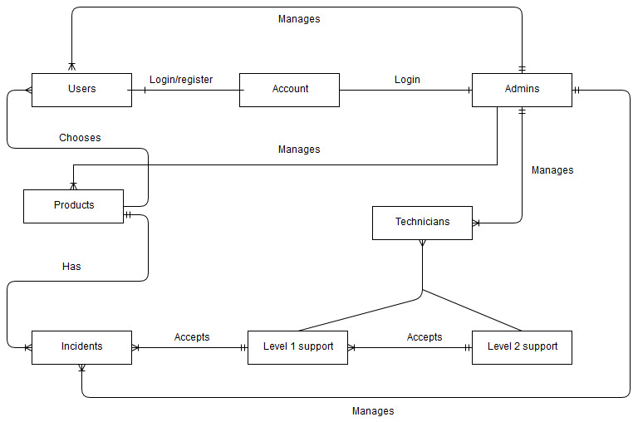

# Complete E-R diagram (to 3NF) FIG 1 – Michael:

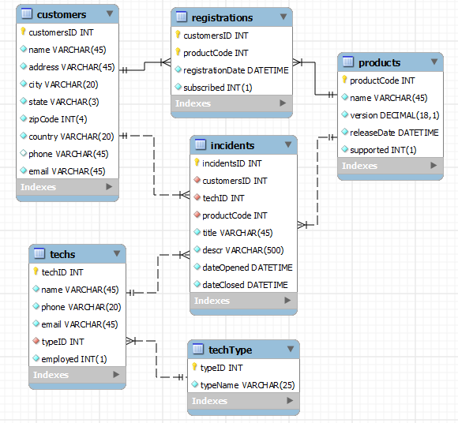

# Complete table data structures

(Ben, Andrei, Waleed, Michael, Corey) See Fig 1

# List table columns/attributes

(Ben, Andrei, Waleed, Michael, Corey) See Fig 1

# Identify primary and foreign keys

(Ben, Andrei, Waleed, Michael, Corey) See Fig 1

# Create test data

**Michael**

**Product Maintenance**

|  |  |  |  |
| --- | --- | --- | --- |
| **Product Code** | **Name** | **Version** | **Release Date** |
| 10 | Test | [1.0](mailto:Y@gmail.com) | 10/03/2017 |

**Andrei**

**Technician Maintenance**

|  |  |  |  |
| --- | --- | --- | --- |
| **Tech ID** | **Name** | **Email** | **Phone** |
| 1 | Andrei Rico | [Y@gmail.com](mailto:Y@gmail.com) | 002323444 |

**Corey**

**Incident Form**

|  |  |  |  |  |  |  |  |  |  |  |  |
| --- | --- | --- | --- | --- | --- | --- | --- | --- | --- | --- | --- |
| **Customer ID** | **Name** | **Address** | **City** | **State** | **Zip** | **Phone** | **Email** | **Product** | **Date Opened** | **Date Closed** | **Title** |
| 1 | Corey | 22 Street | Gold Coast | QLD | 400 | 0283923 | d@yahoo.com | Test | 12/12/2012 | 13/04/2014 | Test |

**Waleed**

**Add Incident Form**

|  |  |  |  |  |  |
| --- | --- | --- | --- | --- | --- |
| **Customer ID** | **Name** | **Date Opened** | **Product** | **Title** | **Description** |
| 1 | Waleed | 13/2/2017 | Test | Test | Test |

**Ben**

**Add Registration Form**

|  |  |  |
| --- | --- | --- |
| **Customer** | **Product** | **Registration Date** |
| Ben | Test | 22/09/2014 |

# GUI Design And Toe Chart – All :

**Michael**

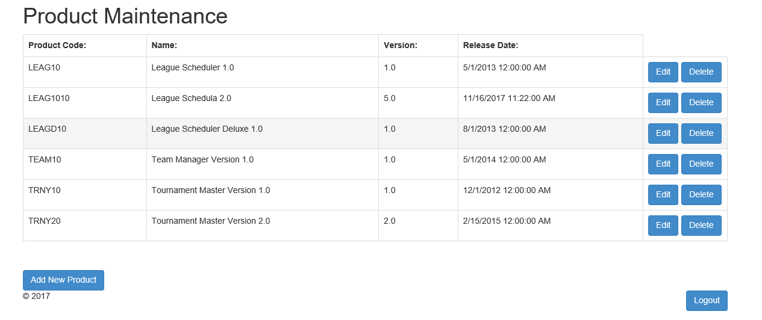

**Product Maintenance**

|  |  |  |
| --- | --- | --- |
| **TASK** | **OBJECT** | **EVENT** |
| Product Code | ItemsTable |  |
| Name | ItemsTable |  |
| Version | ItemsTable |  |
| Release Date | ItemsTable |  |
| Edit | Generated | Click |
| Delete | Generated | Click |
| Add Product | btnAddProduct | Click |
| Logout | btnLogOut | Click |

**Add Poduct**

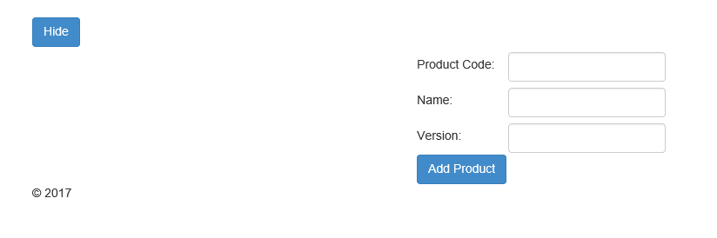

**Add product**

|  |  |  |
| --- | --- | --- |
| **TASK** | **OBJECT** | **EVENT** |
| Hide | btnHide | Click |
| Product Code | txtCode |  |
| Name | txtName |  |
| Version | txtVersion |  |
| Add Product | btnAddProduct | Click |

**Andrei**

**Tech Maintenance**

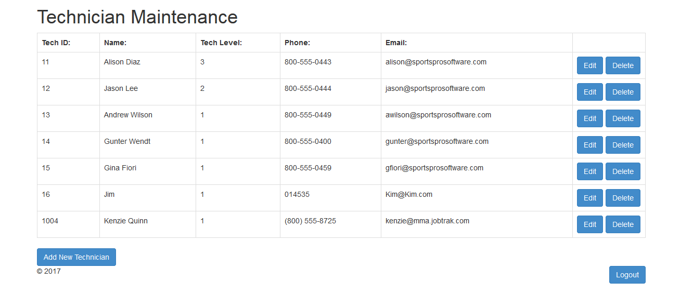

**Technician Maintenance**

|  |  |  |
| --- | --- | --- |
| **TASK** | **OBJECT** | **EVENT** |
| Tech ID | TechnicianTable |  |
| Name | TechnicianTable |  |
| Tech level | TechnicianTable |  |
| Phone | TechnicianTable |  |
| Email | TechnicianTable |  |
| Edit | Generated | Click |
| Delete | Generated | Click |
| Add New technician | btnAdd | Click |
| Logout | btnLogOut | Click |

**Add technician**

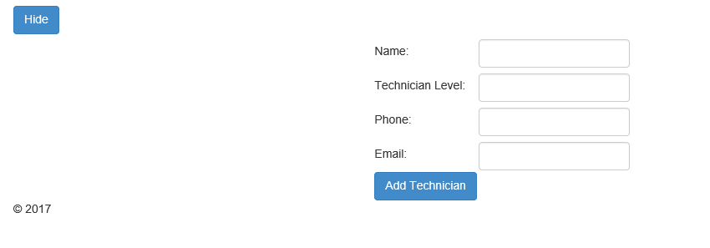

**Add technician**

|  |  |  |
| --- | --- | --- |
| **TASK** | **OBJECT** | **EVENT** |
| Hide | btnHide | Click |
| Name | txtName |  |
| Technician Level | txtLevel |  |
| Phone | txtPhone |  |
| Email | txtEmail |  |
| Add Technician | btnAdd | Click |

**Corey**

**Incident Page**

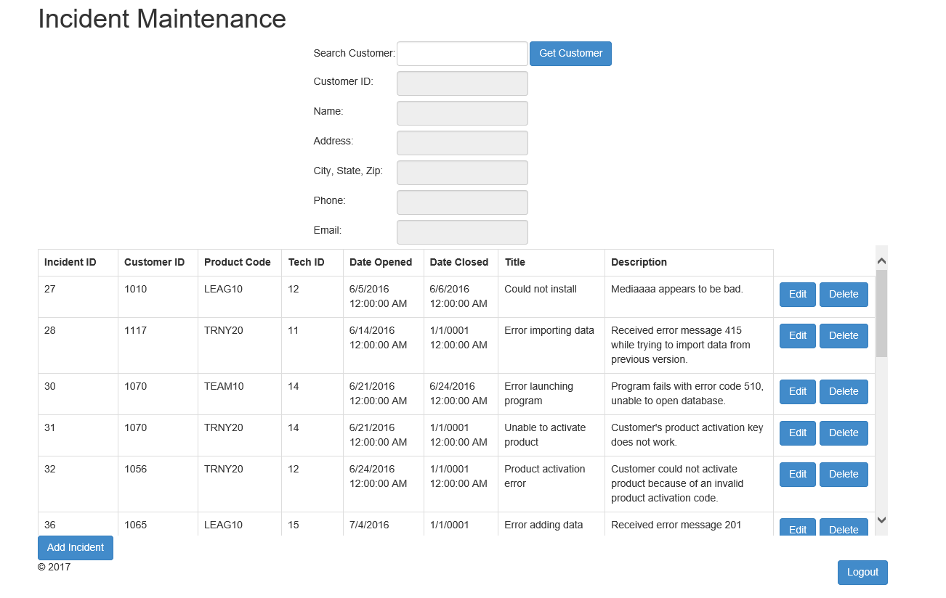

**Incident Page**

|  |  |  |
| --- | --- | --- |
| **TASK** | **OBJECT** | **EVENT** |
| Search Customer | txtBoxCustomer |  |
| Get Customer | btnGetCustomer | Click |
| Customer ID | txtCustomerID |  |
| Name | txtName |  |
| Address | txtAddress |  |
| City,State,Zip | txtCity |  |
| Phone | txtPhone |  |
| Email | txtEmail |  |
| Incident ID | IncidentsTable |  |
| Customer ID | IncidentsTable |  |
| Product Code | IncidentsTable |  |
| Tech ID | IncidentsTable |  |
| Date opened | IncidentsTable |  |
| Date Closed | IncidentsTable |  |
| Title | IncidentsTable |  |
| Description | IncidentsTable |  |
| Edit | Generated | Click |
| Delete | Generated | Click |
| Add Incident | btnAdd | Click |
| Logout | btnLogOut | Click |

**Add Incident**

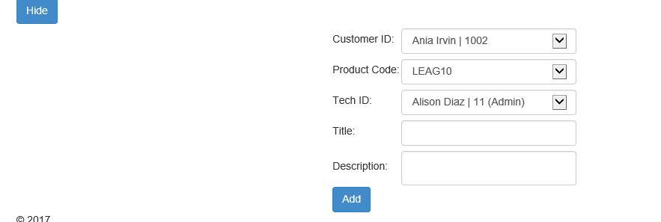

**Add Incident**

|  |  |  |
| --- | --- | --- |
| **TASK** | **OBJECT** | **EVENT** |
| Hide | btnHide | Click |
| Customer ID | dropDownCustomerId | Click |
| Product Code | dropDownCode | Click |
| Tech ID | dropDownTechId | Click |
| Title | txtTitle |  |
| Description | txtDescription |  |
| Add | btnAdd | Click |

**Waleed**

**Edit Incident Page**

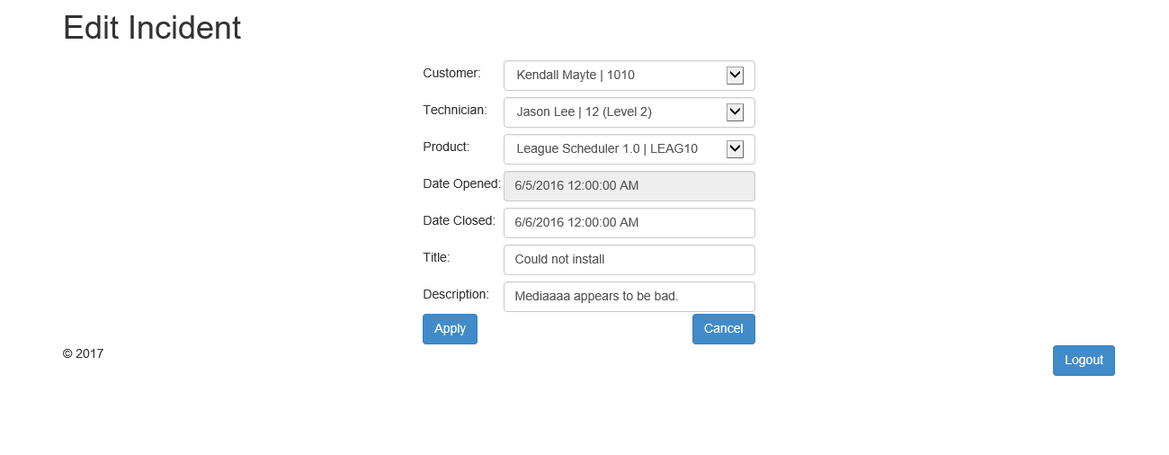

**Edit Incident**

|  |  |  |
| --- | --- | --- |
| **TASK** | **OBJECT** | **EVENT** |
| Customer | dropDownCustomer | Click |
| Technician | dropDownTechnician | Click |
| Product | dropDownProduct | Click |
| Date Opened | txtDateOpened |  |
| Date Closed | txtDate Closes |  |
| Title | txtTitle |  |
| Description | txtDescription |  |
| Apply | btnApply | Click |
| Cancel | btnCancel | Click |
| Logout | btnLogOut | Click |

**Ben**

**Registration Page**

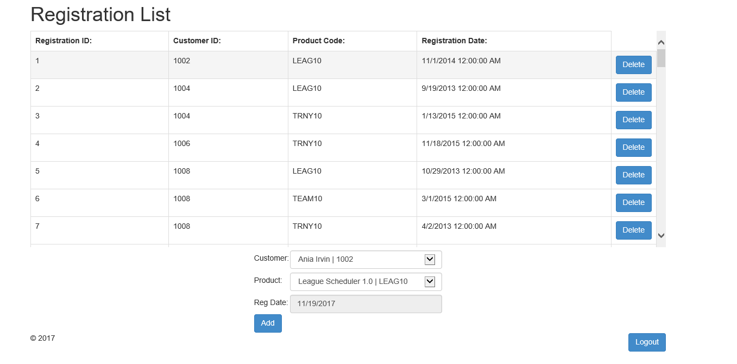

**Registration Page**

|  |  |  |
| --- | --- | --- |
| **TASK** | **OBJECT** | **EVENT** |
| Registration ID | ItemsTable |  |
| Customer ID | ItemsTable |  |
| Product Code | ItemsTable |  |
| Registration Date | ItemsTable |  |
| Delete | Generated | Click |
| Customer | dropDownCustomer | Click |
| Product | dropDownProduct | Click |
| Reg Date | txtDate |  |
| Add | btnAdd | Click |
| Log out | btnLogOut | Click |

# 

# Complete GUI design

**(Michael, Corey, Ben Andrei, Waleed)**

See GUI design for Product Maintenance, Technician Maintenance, Incident Page, Edit Incident page and Registration page.

**Log-in Page**



|  |  |  |
| --- | --- | --- |
| **TASK** | **OBJECT** | **EVENT** |
| Customer ID | txtCustomerId |  |
| Password | txtPassword |  |
| Log-in | btnLog | Click |

**Home Page**

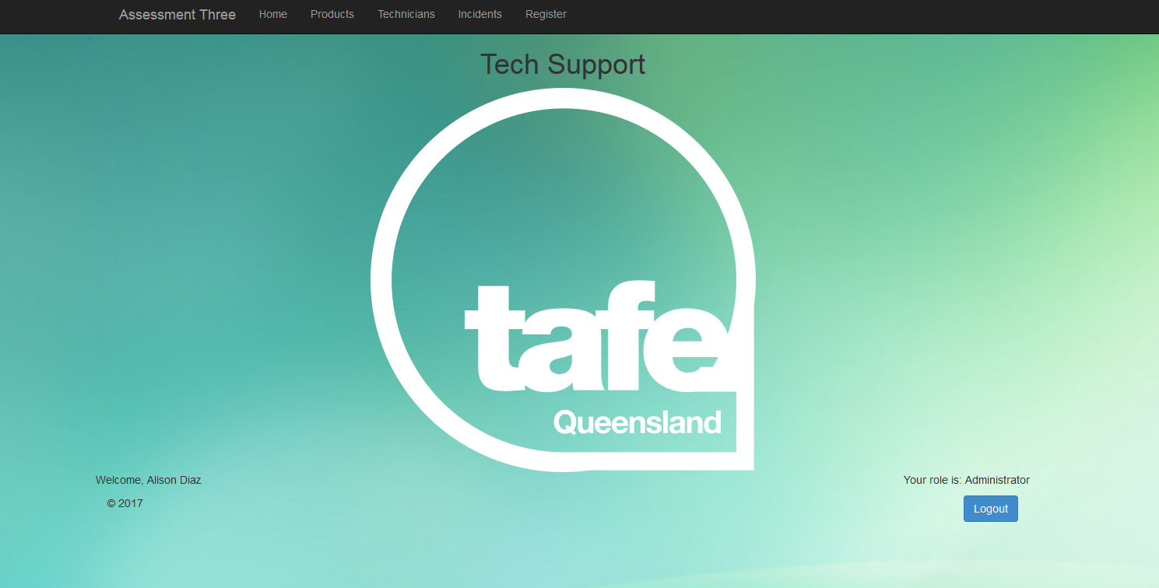

|  |  |  |
| --- | --- | --- |
| **TASK** | **OBJECT** | **EVENT** |
| Home | href | Click |
| Product | href | Click |
| Technicians | href | Click |
| Incidents | href | Click |
| Register | href | Click |
| Log Out | btnLogOut | Click |